**LEBANESE AMERICAN UNIVERSITY**

**USAID – HIGHER EDUCATION SCHOLARSHIP PROGRAM**

**HES - Volunteering Program Verification Form**

This form is to be used to document volunteering hours. If a student volunteers for multiple organizations, a separate form must be used for each organization. **This form must be turned in by the 28th of each month, the latest.**

I certify that the scholar Riwa kassem completed a total of 2 hours of service at InnovaThrive.

The hours were completed hours as per the below:

Hours # 0 (date) _2/12 – 6/12_ (initials of supervisor) __A.K.___

Hours # 0 (date) _9/12 – 13/12_ (initials of supervisor) __A.K.___

Hours # 2 date) _16/12 – 20/12 (initials of supervisor) __A.K.___

Hours # 0 date) _23/12 - 27/12 (initials of supervisor) __A.K.___

Brief description of the activities the scholar performed or participated in:

As a volunteer on a research team, I conducted a research focused on The Influence of AI in Revolutionizing Retail Inventory Management.  
My research explored the Definition: AI’s impact on optimizing inventory management systems in retail.  
  
One of the key questions I researched was Technologies and especially :Predictive analytics for forecasting demand and supply.  
Computer vision for real-time shelf monitoring,and applications:Automating stock replenishment processes in supermarkets.Reducing overstock and understock scenarios.  
Statistics: Reports showing up to a 40% reduction in inventory carrying costs due to AI.

Written feedback about the scholar’s performance:

Riwa Kassem’s analysis of AI in retail inventory management highlighted significant advancements, focusing on predictive analytics and automation, contributing to more efficient retail operations.

Please rate the overall performance of the scholar at your organization:

|  |  |  |  |
| --- | --- | --- | --- |
|  | Mastery (5) | Proficient (3) | Emerging (1) |
| **Problem solver** | X |  |  |
| **Engaged & Committed** | X |  |  |
| **Open-minded & multicultural** | X |  |  |

Signature

& stamp

__________________________

_

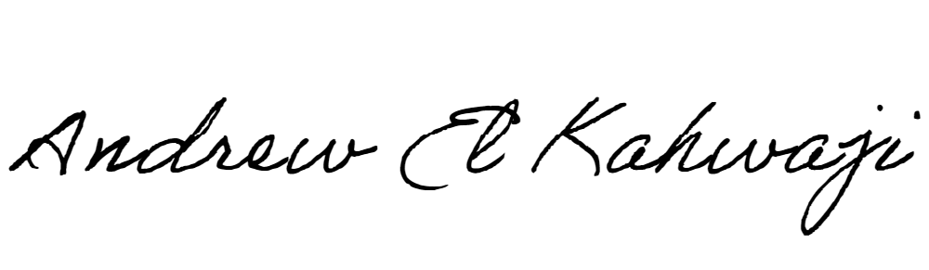

Printed Name _Andrew El Kahwaji_

Date __26/12/2024___

Email __andrew.lifesculptor.coo@gmail.com __

Phone __+961 71 914 378__